ORALSCAN AI_Y2
YOLO26-M Instance Segmentation
Complete Reverse Engineering & Technical Study Document

Reference artifacts: ai_y2(1).pt (final checkpoint) and ai_y2(2).ipynb (development notebook)
Purpose: complete study, reproducibility, architecture understanding, model selection, evaluation and Y1-compatible classifier integration.
Document method: recorded notebook outputs are distinguished from conceptual explanation; no new held-out evaluation was run.

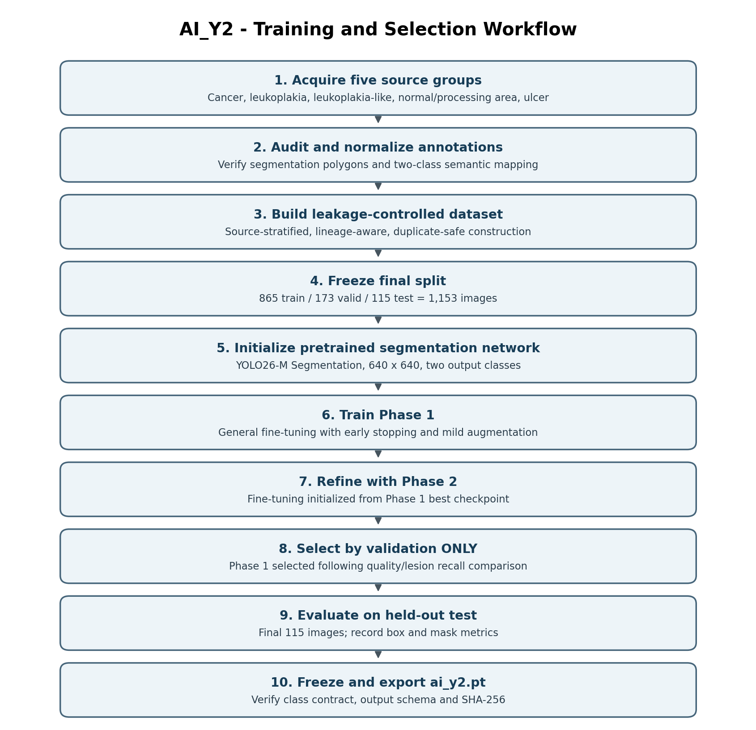

1. One-Page Quick Reference
Item | Final AI_Y2 configuration
Task | Oral instance segmentation (processing area / lesion)
Architecture | YOLO26-M segmentation; yolo26m-seg.yaml
Initial checkpoint | yolo26m-seg.pt
Frozen model | ai_y2.pt — selected Phase 1 best candidate
Input size | 640 x 640
Class mapping | 0 = processing_area; 1 = lesion
Final clean dataset | 1,153 images
Split | 865 train | 173 valid | 115 test
Training process | Two phases; validation-only selection
Chosen candidate | Phase 1
Final mask precision / recall | 0.6550 / 0.5940
Final mask mAP50 / mAP50–95 | 0.4835 / 0.2178
Lesion-positive image detection | 82/89 (92.13%)
Processing-only false lesion image rate | 2/26 (7.69%)
Downstream role | ROI and geometry generator for independent classifier models
Study Note: AI_Y2 is a segmentation/localization model, not a five-class disease classifier.

2. Objectives and Role in OralScan
AI_Y2 is designed to replace or complement AI_Y1 without changing the external detector class contract. Its task is to identify the oral processing region and lesion instances, then expose their masks, boxes and confidence measurements to an independent classifier adapter.
- Find processing_area (ID 0) and lesion (ID 1) instances in the same input image.
- Return bounding boxes, confidence values, instance masks and polygon coordinates.
- Support image-level presence flags and ROI cropping in downstream software.
- Avoid requiring an AI_Y2-specific classifier input interface.

3. Source Data and Dataset Engineering
The notebook builds the Y2 dataset from five source groups: cancer, leukoplakia, leukoplakia-like, processing-area/normal and ulcer. Disease-specific categories are remapped to the common lesion output class; the detector itself does not predict disease names.
Source group | Final source images | Train | Valid | Test
Cancer | 200 | 150 | 30 | 20
Leukoplakia | 246 | 184 | 37 | 25
Leukoplakia-like | 249 | 187 | 37 | 25
Processing area | 264 | 198 | 40 | 26
Ulcer | 194 | 146 | 29 | 19
TOTAL | 1153 | 865 | 173 | 115
A prior dataset-building cell reported 855/179/119. The corrected final frozen split in Module 1 Cell 4 and subsequent Module 2 processing is 865/173/115. This document uses the latter for production reporting.

3.1 Frozen class contract
Class 0: processing_area. Class 1: lesion. Both class IDs and spellings are identical to the AI_Y1 detector contract.
YOLO polygon annotation format: class_id x1 y1 x2 y2 ... xn yn. Coordinates are normalized to the image dimensions.

3.2 Dataset audit, leakage and integrity
- Lineage groups across different train/valid/test splits: 0 reported.
- Exact MD5 image overlap across train/valid/test splits: 0 reported.
- Final source-stratified split targets checked against source-group totals.
- Final polygon object counts: train processing=900, lesion=787; valid processing=179, lesion=157; test processing=120, lesion=105.
- Final dataset contains exactly 1,153 images; cleaned class mapping is retained in data.yaml.
Study Note: Group-aware and exact-duplicate checks reduce leakage risk but are not substitutes for prospective external clinical validation.

4. Reverse-Engineered Neural Architecture
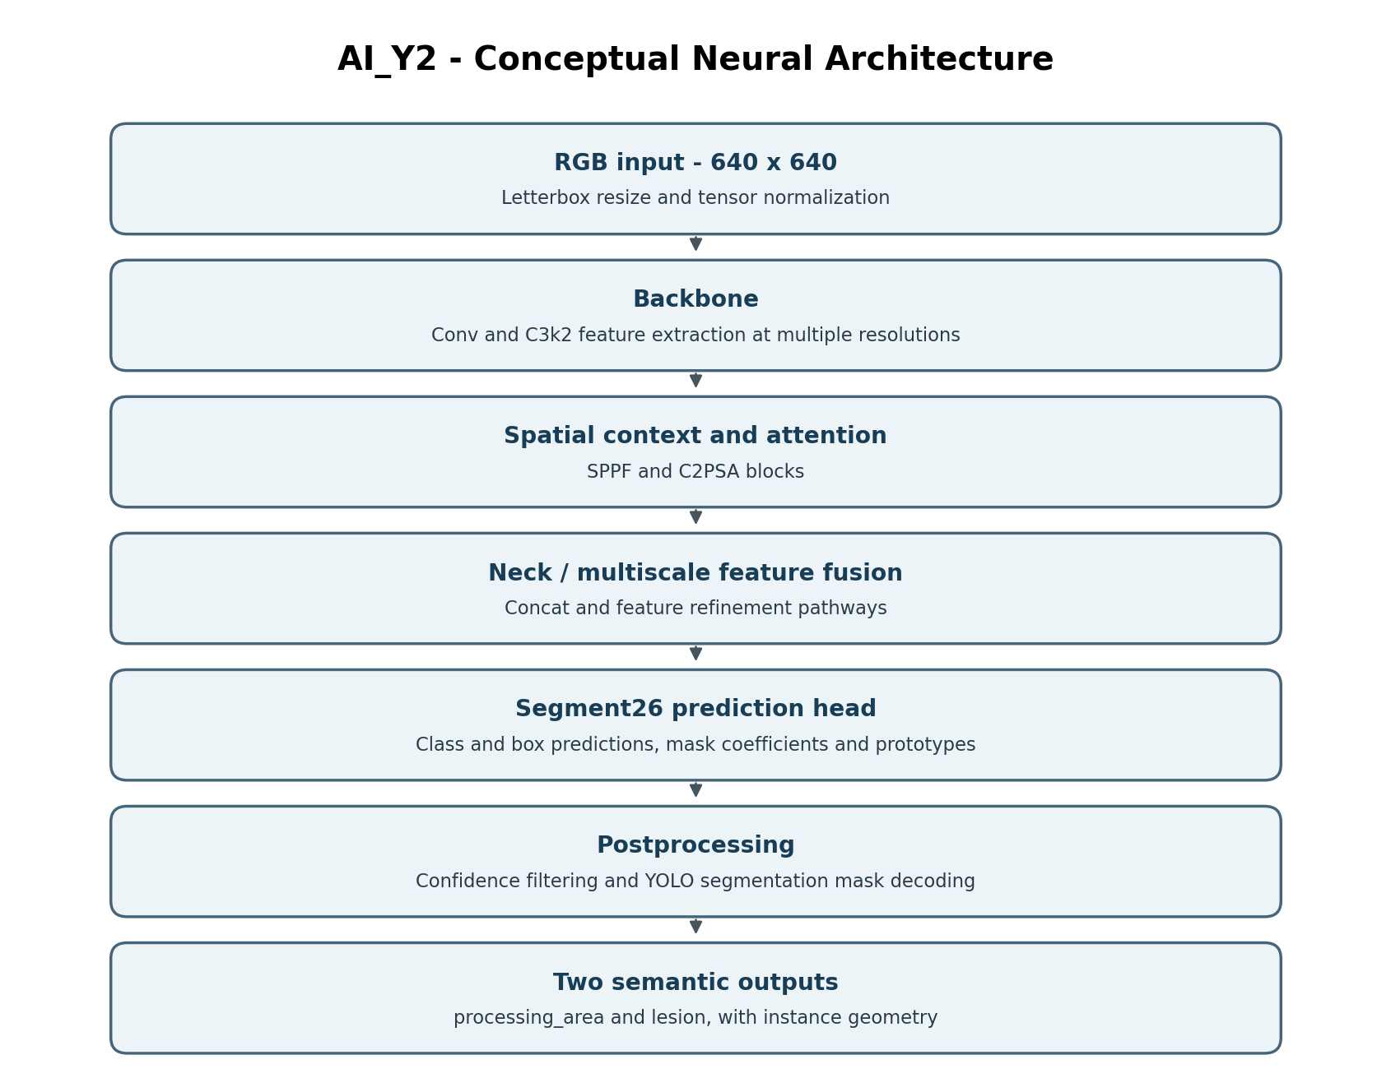
The checkpoint identifies the YOLO26-M segmentation family and components including Conv, C3k2, SPPF, C2PSA, Concat and Segment26. The figure describes component roles; it is not an instrumented layer-by-layer tensor trace.

4.1 Backbone: convolutional feature extraction
Convolutional layers learn edges, texture and higher-level visual patterns. C3k2 blocks reuse features efficiently, while SPPF increases contextual receptive-field coverage. C2PSA adds attention-based contextual interactions.
Conceptual convolution: Y(i,j) = sum[m,n] X(i+m,j+n) K(m,n) + b.

4.2 Neck and segmentation head
The neck fuses coarse semantic representations with finer spatial details for variable-sized targets. The Segment26 head generates class/box-related information and instance-mask components. Conceptual mask construction: M_i(x,y) = sigmoid(sum_k c_ik P_k(x,y)), followed by geometry-aware postprocessing.
Study Note: The conceptual mask formula explains prototype-style segmentation and is not presented as a verbatim dump of the installed model forward method.

5. Model Training: Two-Phase Strategy
Setting | Phase 1 | Phase 2
Starting model | Pretrained YOLO26-M seg | Phase 1 best
Max epochs | 350 | 120
Patience | 55 | 30
Initial learning rate | 0.0004 | 0.00010
Warmup | 4 epochs | 2 epochs
Degrees | 8 | 3
Translation | 0.04 | 0.02
Scale | 0.12 | 0.05
Horizontal flip | 0.50 | 0.50
Mosaic | 0.10 | 0.00
Copy-paste | 0.00 | 0.00
Phase 1 trains the backbone/head with conservative clinical-image augmentation. Phase 2 starts from the Phase 1 best weights and uses smaller learning rate and gentler geometry transformations. Both phases maintain the same output class scheme.
The notebook records Phase 1 training duration of 59.60 minutes and Phase 2 duration of 11.41 minutes for the respective recorded Colab run.

6. Validation-Based Candidate Selection
Validation metric @ conf=0.25 | Phase 1 | Phase 2
Mask precision | 0.7337 | 0.7400
Mask recall | 0.6393 | 0.6388
Mask mAP50 | 0.5661 | 0.5586
Mask mAP50–95 | 0.2629 | 0.2649
Lesion mask mAP50–95 | 0.2821 | 0.2577
Lesion-image recall | 0.9398 | 0.8421
False-lesion image rate | 0.1750 | 0.0750
Selection score | 0.575477 | 0.554232
The validation-selection cell recommended Phase 1. Phase 2 had a lower false-lesion image rate at the primary operating point, but Phase 1 had higher lesion presence recall and the notebook’s aggregate selection score. The test set was deliberately reserved until this decision was made.

7. Held-Out Test Performance: Frozen AI_Y2
The notebook recorded one final evaluation of the selected candidate on the 115-image test partition.
Metric | Final value
Mask precision | 0.6550
Mask recall | 0.5940
Mask mAP@50 | 0.4835
Mask mAP@50–95 | 0.2178
Box precision | 0.8192
Box recall | 0.7270
Box mAP@50 | 0.6960
Box mAP@50–95 | 0.4247
Processing-area mask mAP@50–95 | 0.2539
Lesion mask mAP@50–95 | 0.1817
Image-level detection check | Recorded value
Images with ground-truth lesion | 89
Images with lesion detected | 82
Lesion image-level recall | 92.13%
Processing-only images | 26
Processing-only images with false lesion | 2
False lesion image-level rate | 7.69%
Interpretation: the model detects the presence of a lesion in most test lesion-positive images, but its instance mask overlap is substantially less precise at strict IoU thresholds. This matters when downstream lesion crop quality depends on segmentation boundaries.

7.1 Definitions of evaluation quantities
- Precision = TP / (TP + FP).
- Recall = TP / (TP + FN).
- IoU = intersection area / union area between prediction and ground truth.
- mAP@50 evaluates detection/segmentation AP at IoU 0.50.
- mAP@50–95 averages AP across IoU thresholds 0.50 to 0.95.
- Image-level lesion recall differs from object-level segmentation recall.

8. Checkpoint Serialization and Reverse Engineering
ai_y2(1).pt is a PyTorch checkpoint containing serialized learned tensors and associated model/training metadata. The architecture metadata identifies segmentation task components including Segment26. A checkpoint is not equivalent to executable training source code; the .ipynb supplies the development process.
Recorded frozen checkpoint SHA-256: 6c80c9a9449dd99362aba69c1a2e18e71619b38ffad53478b6211b0f20cf4b93.
Uploaded checkpoint independently computed SHA-256: 6c80c9a9449dd99362aba69c1a2e18e71619b38ffad53478b6211b0f20cf4b93.
Fingerprint match: YES — the uploaded checkpoint matches the notebook-recorded frozen model.
Study Note: For safety, untrusted PyTorch pickled checkpoints should not be deserialized outside a trusted environment.

9. Inference, Result Schema and Classifier Handoff
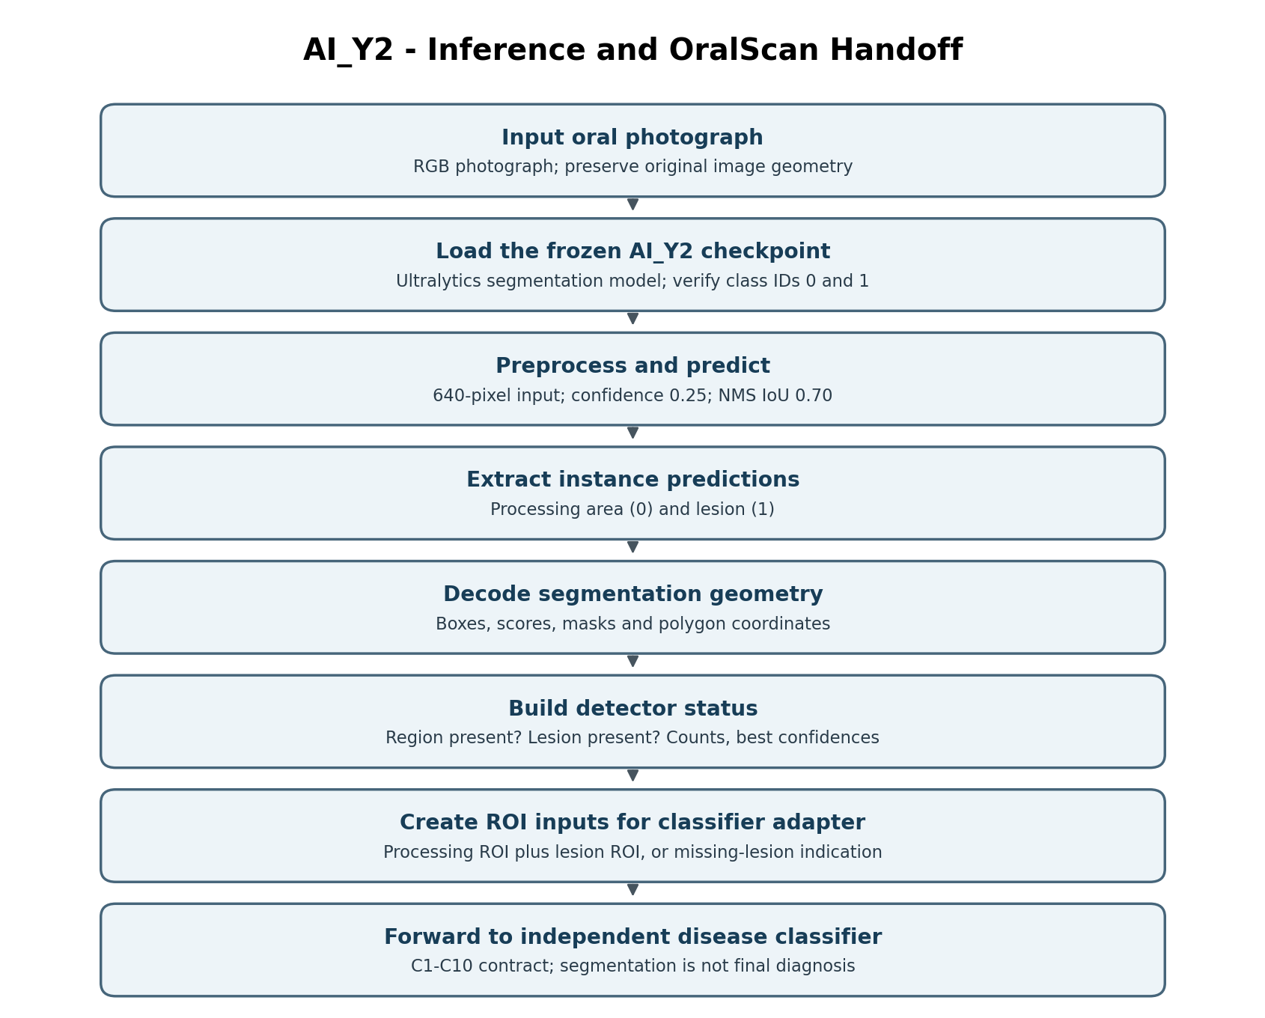
Runtime / output item | Contract
Checkpoint | ai_y2.pt
Classes | 0 processing_area; 1 lesion
imgsz | 640
Confidence | 0.25
NMS IoU | 0.70
boxes.cls | Predicted class IDs
boxes.conf | Detection confidence
boxes.xyxy | Bounding boxes in pixel coordinates
masks.data | Segmentation-mask arrays, if any
masks.xy | Polygon coordinates, if any
The ROI adapter should preserve image-coordinate mapping and handle absent detections. If the processing area is missing, full-image fallback is a possible system-level policy. If the lesion is missing, the downstream dual-ROI classifier receives a missing-lesion indication instead of an invented lesion crop.
The inference pipeline can support many compatible classifier versions without requiring a separate Y2-specific interface. Diagnostic class probabilities are produced by the selected classifier, not by AI_Y2.

10. Later Notebook Experiments (Not the Frozen Checkpoint)
Additional cells analyzed validation failures, ground-truth geometry, hard examples and mask boundary refinement; they also built five-fold out-of-fold (OOF) predictions and a training-only weighted hard-case dataset.
Later experiment | Recorded status
Boundary-focused candidate | Saved separately; production ai_y2.pt not overwritten
Five-fold OOF training | Used to mine training-set hard examples
OOF weighted train set | 865 original + 345 selected additional entries = 1,210 train entries
Weighted retraining candidate | Validated separately; no automatic promotion
Final uploaded ai_y2.pt | Remains Phase 1 selected production checkpoint
The OOF-weighted candidate improved some validation metrics but reduced the lesion mask mAP50–95 from ~0.2823 to ~0.2370; the notebook explicitly deferred promotion.

11. Engineering Limitations
- No independent new test inference is represented by this documentation: metrics are from recorded notebook output.
- Clinical performance can differ across acquisition devices, anatomy, lighting, severity and patient populations.
- High image-level detection recall does not ensure accurate mask boundaries.
- The .pt file must be loaded and forward-tested under an Ultralytics/PyTorch environment compatible with its serialized classes.
- The two-class detector cannot distinguish cancer, leukoplakia, ulcers or normal diagnostic classes on its own.

12. Reproducibility Checklist
- Recover or recreate the five source groups with verified polygon annotations.
- Confirm exact semantic class contract: processing_area=0, lesion=1.
- Build the final corrected 865/173/115 group-aware split and inspect leakage reports.
- Freeze and fingerprint dataset artifacts before model training.
- Use YOLO26-M segmentation and the notebook’s Phase 1 / Phase 2 settings.
- Compare checkpoints on validation data before accessing the held-out test partition.
- Copy only the selected best candidate to ai_y2.pt and verify its SHA-256.
- Check output attributes and missing-result behavior under the deployment environment.
- Validate clinically on independent acquisition sites before diagnostic reliance.

13. Study Summary
Question | Answer
What is AI_Y2? | Two-class YOLO26-M oral instance segmentation detector.
How many final output classes? | Two: processing_area and lesion.
Does it diagnose cancer? | No. Separate downstream classifier performs diagnostic classification.
What is the final dataset? | 1,153 images; 865 train, 173 valid, 115 test.
Which candidate was selected? | Phase 1 checkpoint, after validation comparison.
What is the final segmentation test mAP50–95? | 0.2178.
Why keep two-stage separation? | Independent detector and classifier versions share a consistent ROI interface.
Did later OOF experiments replace Y2? | No.

14. Source Provenance and Scope
Primary source 1: ai_y2(2).ipynb — source code and recorded cell outputs for dataset construction, class mapping, two-stage training, validation selection, final held-out test, export and follow-on experiments.
Primary source 2: ai_y2(1).pt — uploaded model checkpoint. SHA-256 verified against the notebook-recorded final SHA-256.
Style reference: AI_Y1 Doc.docx — page structure, study-guide tables, workflow diagrams and technical documentation framing.
All architecture explanations, formulae and software integration notes are labeled by their explanatory or proposed nature when not a direct notebook result. No external sources were used for the reported experiment values.

